***Inner Classes***

**For more details on SUN Certifications, visit** [**JavaScjpDumps**](http://www.javascjpdumps.blogspot.com/)

**Q: 01 Given:**

**11. public class Test {**

**12. public static void main(String [] args) {**

**13. int x = 5;**

**14. boolean b1 = true;**

**15. boolean b2 = false;**

**16.**

**17. if ((x == 4) && !b2 )**

**18. System.out.print("1 ");**

**19. System.out.print("2 ");**

**20. if ((b2 = true) && b1 )**

**21. System.out.print("3 ");**

**22. }**

**23. }**

**What is the result?**

A. 2

B. 3

C. 1 2

**D. 2 3**

E. 1 2 3

F. Compilation fails.

G. An exception is thrown at runtime.

**Answer: D Executed**

**Q: 02 Given the command line java Pass2 and:**

**15. public class Pass2 {**

**16. public void main(String [] args) {**

**17. int x = 6;**

**18. Pass2 p = new Pass2();**

**19. p.doStuff(x);**

**20. System.out.print(" main x = " + x);**

**21. }**

**22.**

**23. void doStuff(int x) {**

**24. System.out.print(" doStuff x = " + x++);**

**25. }**

**26. }**

**What is the result?**

A. Compilation fails.

**B. An exception is thrown at runtime.**

C. doStuff x = 6 main x = 6

D. doStuff x = 6 main x = 7

E. doStuff x = 7 main x = 6

F. doStuff x = 7 main x = 7

**Answer: B**

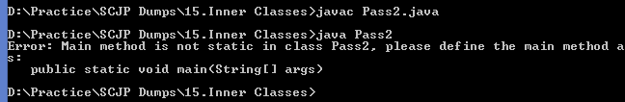

**Q: 03 Given:**

**13. public class Pass {**

**14. public static void main(String [] args) {**

**15. int x = 5;**

**16. Pass p = new Pass();**

**17. p.doStuff(x);**

**18. System.out.print(" main x = " + x);**

**19. }**

**20.**

**21. void doStuff(int x) {**

**22. System.out.print(" doStuff x = " + x++);**

**23. }**

**24. }**

**What is the result? Executed**

A. Compilation fails.

B. An exception is thrown at runtime.

C. doStuff x = 6 main x = 6

D. doStuff x = 5 main x = 5

E. doStuff x = 5 main x = 6

F. doStuff x = 6 main x = 5

**Answer: D**

**Question: 04**

**Given:**

**42. public class ClassA {**

**43. public int getValue() {**

**44.int value=0;**

*45.* **boolean setting = true;**

**46. String title=”Hello”;**

**47. if (value || (setting && title == “Hello”)) { return 1; }**

**48. if (value == 1 & title.equals(”Hello”)) { return 2; }**

**49. }**

*50.* **}**

**And:**

**70. ClassA a = new ClassA();**

**71. a.getValue();**

**What is the result?**

A. 1

B. 2

C. Compilation fails.

D. The code runs with no output.

E. An exception is thrown at runtime.

**Answer: C**

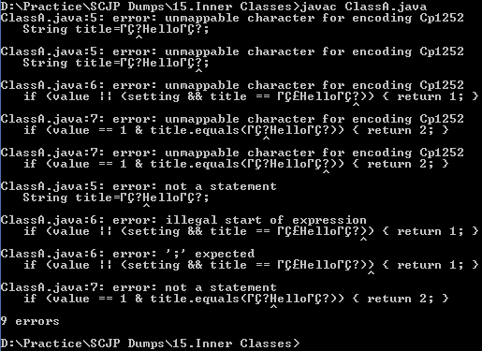

**5. Given:**

**class Hexy {**

**public static void main(String[] args) {**

**Integer i = 42;**

**String s = (i<40)?"life":(i>50)?"universe":"everything";**

**System.out.println(s);**

**} }**

**What is the result?**

A. null

B. life

C. universe

**D. everything**

E. Compilation fails.

F. An exception is thrown at runtime.

**Answer:**

-> **D** is correct. This is a ternary nested in a ternary with a little unboxing thrown in.

Both of the ternary expressions are false.

**-> A, B, C, E,** and **F** are incorrect based on the above.

**6. Given:**

**1. class Example {**

**2. public static void main(String[] args) {**

**3. Short s = 15;**

**4. Boolean b;**

**5. // insert code here**

**6. }**

**7. }**

**Which, inserted independently at line 5, will compile? (Choose all that apply.)**

A. b = (Number instanceof s);

**B. b = (s instanceof Short);**

C. b = s.instanceof(Short);

**D. b = (s instanceof Number);**

E. b = s.instanceof(Object);

F. b = (s instanceof String);

**Answer:**

-> **B** and **D** correctly use boxing and instanceof together.

-> **A** is incorrect because the operands are reversed. **C** and **E** use incorrect instance of syntax. **F** is wrong because Short isn't in the same inheritance tree as String.